Debugging Exercise 1: Array Manipulation

Objective: To identify and fix errors in a Java program that manipulates arrays.  
  
public class Array Manipulation {

    public static void main(String[] args) {

        int[] numbers = {1, 2, 3, 4, 5};

        for (int i = 0; i <= numbers. Length; i++) {

            System.out.println(numbers[i]);

        }

    }

}

* CHANGED CODE

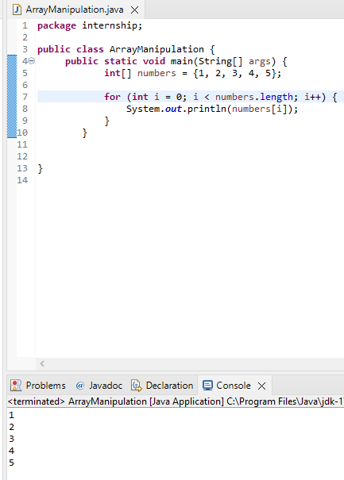

Debugging Exercise 2: Object-Oriented Programming

Objective: To identify and fix errors in a Java program that demonstrates basic object-oriented programming principles.  
  
class Car {

    private String make;

    private String model;

    public Car(String make, String model) {

        this.make = make;

        this.model = model;

    }

    public void start() {

        System.out.println("Starting the car.");

    }

}

public class Main {

    public static void main(String[] args) {

        Car car = new Car("Toyota", "Camry");

        car.start();

        car.stop();

    }

}

* CHANGED CODE

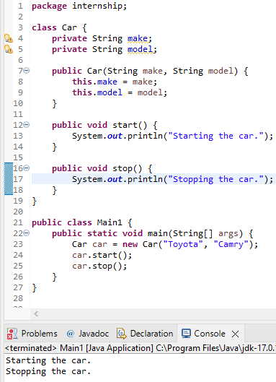

Debugging Exercise 3: Exception Handling

Objective: To identify and fix errors in a Java program that demonstrates exception handling.

public class ExceptionHandling {

    public static void main(String[] args) {

        int[] numbers = {1, 2, 3, 4, 5};

        try {

            System.out.println(numbers[10]);

        } catch (ArrayIndexOutOfBoundsException e) {

            System.out.println("Array index out of bounds.");

        }

        int result = divide(10, 0);

        System.out.println("Result: " + result);

    }

    public static int divide(int a, int b) {

        return a / b;

    }

}

* CHANGED CODE

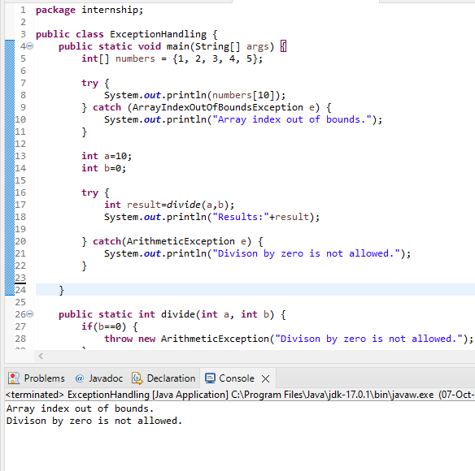

Exercise 4:  
public class Fibonacci {

    public static int fibonacci(int n) {

        if (n <= 1)

            return n;

        else

            return fibonacci(n-1) + fibonacci(n-2);

    }

    public static void main(String[] args) {

        int n = 6;

        int result = fibonacci(n);

        System.out.println("The Fibonacci number at position " + n + " is: " + result);

    }

}

* CHANGED CODE

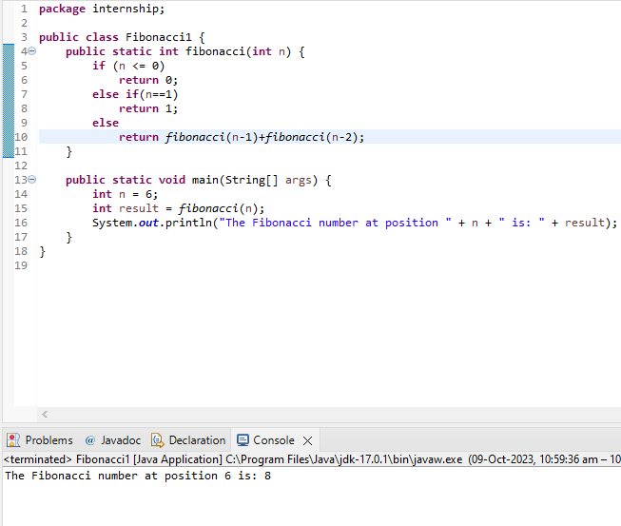

Excercise 5

import java.util.\*;

public class PrimeNumbers {

    public static List<Integer> findPrimes(int n) {

        List<Integer> primes = new ArrayList<>();

        for (int i = 2; i <= n; i++) {

            boolean isPrime = true;

            for (int j = 2; j < i; j++) {

                if (i % j == 0) {

                    isPrime = false;

                    break;

                }

            }

            if (isPrime) {

                primes.add(i);

            }

        }

        return primes;

    }

    public static void main(String[] args) {

        int n = 20;

        List<Integer> primeNumbers = findPrimes(n);

        System.out.println("Prime numbers up to " + n + ": " + primeNumbers);

    }

}

* CHANGED CODE

